John Peden

1.

a. We are starting from looking at the back, right, and top side of the cube, this will change the eye to look at the left (yellow) side of the cube, since we are moving negative 4 places on the x axis.

b. This will have us looking at the front, top, and right side of the cube. We’re changing the position to + 3 on the x, y, and z axis.

c.

d. by changing the ortho, we changed the viewing area which skewed the cube to be much taller and thinner.

e. Now we changed the viewing area to look at the top left corner of the plane which is only giving us the left corner of the cube

2. mvMatrix: -0.707 0 -0.707 0

-0.408 0.816 -0.408 -3.264

0.577 0.577 -0.577 -6.924

0 0 0 1

I’ve provided the work for this below.

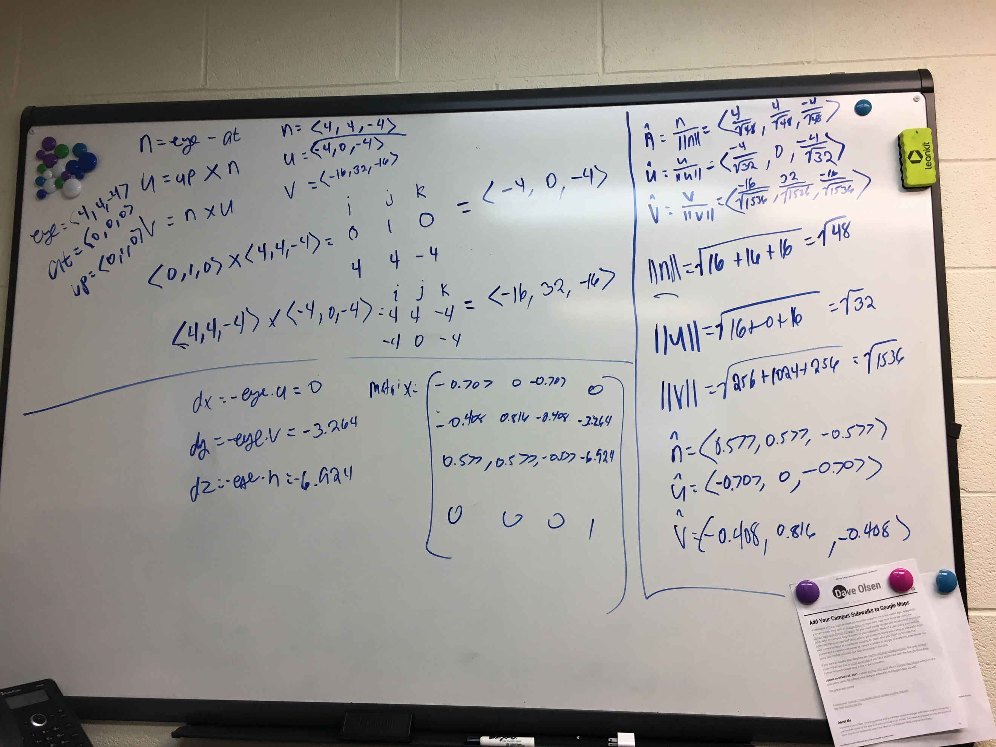

pMatrix: 0.5 0 0 0

0 0.25 0 0

0 0 0.1 0

0 0 0 1

coordinates of a point F(1, 1, -1): (0.5, 0.25, -0.1)

3.

aspect = (2 +2)/(4+4) = 1/2

viewAngle = 2*arctan(1/2*(8)/4) = pi/2

**perspective(pi/2, ½, 4, 10);**

4.